**INTRODUCTORY MEETING WITH ELITE TECHNOLOGY**

DATE: Saturday 19th October 2024

Time: 3:30 pm

**Table of contents**

Introduction of attendees, their majors, their various specialities and their goals of the internship.

Meeting overview.

Elite technology overview.

Expectations and evaluation.

Tasks assigned

Conclusion of meeting.

**Introduction of attendees, their majors, their various specialities and their goals of the internship.**

MR MBAH ALAIN, (Who introduced himself as the chairperson of the meeting and owner of Elite Technology).

HANS, (A level 4 software engineering, student, whose goal of the internship was to help do his final year project which he made mention of developing an application and he made mention of having many final year projects in mind and was in decisive yet

Johannes (A level 4 software engineering student) who said he had a background knowledge of web development and wanted to enhance his knowledge whose goal of the internship was to help do his final year project and he made mention of having many final year projects in mind and was in decisive yet.

Tayong Fritz (A level 4 software engineering student) who said he desired to study software engineering in mobile web development whose goal of the internship was to help do his final year project and he made mention of having many final year projects in mind and was in decisive yet.

Simo Libby (A computer science student, whose goal was to gain more practical experience and also help her do her final year project which was indecisive of which project she will do in the meanwhile.

Afise Pride (A computer science student, whose goal was to gain more practical experience and also help her do his final year project which was indecisive of which project he will do in the meanwhile.

Asaha Christal (A cyber security student whose main goal of the internship was to gain hands on and practical experience in cyber security tools and technologies, opportunity to work on real life projects. She was asked if she has a practical experience which she denied and said she had more of theoretical knowledge than practical but was willing to learn.

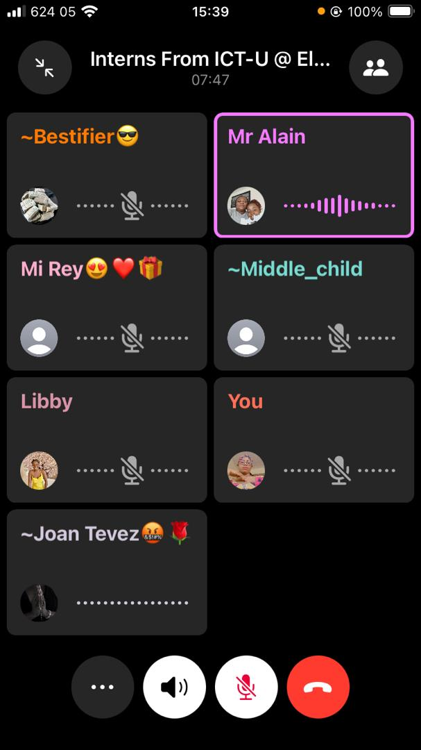

Above is a screenshot of the attendee of yesterday’s meeting.

**Meeting Overview**

The introductory meeting with MR MBAH ALLAIN AZAH Owner of ELITE Technology commenced at 3:30 PM, marking the beginning of our collaboration. Mr. Allain welcomed all interns to ELITE TECHNOLOGY introducing himself and the company's focus on digital marketing, web development, and mobile app building.

**ELITE Technology Overview**

Mr. ALLAIN elaborated on ELITE Technology's mission, focusing on:

1.⁠ ⁠Software app development

2.⁠ ⁠Graphic designing

3.⁠ ⁠Digital marketing

**Expectations and Tasks**

Mr Allain emphasized on the following points as per the expectations and tasks

He Made mention of ICT University students being very lazy as per projects as he himself was from there too and said laziness will not be tolerated and would like that at the internship everyone should leave with an A grade for internship.

•⁠ ⁠Weekly tasks will be assigned to all interns and expected to be done well and perfectly.

•⁠ ⁠Evaluations of assigned tasks will be evaluated every Friday. No delays will be tolerated in case of any delay inform the boss (Mr Allain giving him tangible reasons for your delay and why he should increase the timeframe.

•⁠ ⁠Employee-employer relationship.Mr Allain said our relationship with him wont be student teacher relationship but boss-worker relationship as we are working per clients demand.

•⁠ ⁠Tasks will be completed on Google Docs and GitHub and access should be granted to him in order to access the task done and for him to be able to edit it.

•⁠ ⁠Mister Allain emphasized the importance of quality work, aiming for A-grade performance

**Tasks Assigned for the week.**

**Task 1 Software Engineers**

Develop a basic html website with following this table and write a documentation of your

Methodology e.g. agile methodology E.g.

Write about the project co eceptualuzation (why you need a portfolio website for yourself)

Write about the design tools you used which could be Figma etc

Write a about the development phase (with evidence 3 screenshots of how you worked on the project or development phase) the ID chosen and a lithe about the language used i.e. the role on html in web development.

Finish uploading your code to GitHub pages and sending me a link by Friday 8pm this work closes me sure you submit just two links

1 a link to the website

2) a link to your Google docs documentation

Here is the link of the website to be replicated

https://www.behance.net/gallery/93356117/Web-Developer-Designer-Portfolio-Website-Design?tracking_source=search_projects|web+design+portfolio+website&l=4

**TASK 1 COMPUTER SCIENCE**

Write a little research paper on front web development particularly with html, CSS and Java script. Duel your focus on html as a markup language for developing websites and generally the technologies and best practices for developing professional websites.

Your report should be a standard research work which with heading such as introduction, and conclusion to start and end the paper. Remember to site your references in every research you do the referencing style is APA.

**Task 1 Cyber security**

Build a network sniffer in Python that captures and analyses network traffic.

Write about the libraries used

Upload your code to GitHub and send me a link

Make an appraisal of what the project has thought you.

The deadline for the projects to be evaluated was 8 pm.

Mr Allain told the interns in case of any worries or questions it should be directed to him and also asked interns to discuss their progress on their projects in the WhatsApp group.

**Conclusion of meeting**

Mr Allain wished the interns good luck and announced the next meeting on Friday

The introductory meeting with ELITE Technology marked the beginning of an exciting collaboration. With clear expectations and a shared vision, the team is poised for innovative achievements.